PORTABLE BIOMETRIC ATTENDANCE MANAGEMENT SYSTEM

Srushti Santosh Kadam, Sanjana Ravindra Sawant

Department of Electronics and Communication

Usha Mittal institute of technology

SNDT University, Juhu Tara Road, Santacruz West, Mumbai, Maharashtra-400049

***Abstract* -** This paper deals with biometric, portable, fingerprint attendance system. This project focuses attendance recording system of students. Biometric is anything and everything that can be measured in human beings. Fingerprint is form of biometric identification which is unique and does not change in one’s entire lifetime. This paper presents a portable biometric attendance management system. We have tried to bring together concept of hardware and software engineering to give a prototype project which can further replace current manner of attendance marking. This project utilizes fundamental of internet for data transfer, storage and display. This project consists of two procedures; enrollment and identification. During the enrollment process the fingerprint of the person is captured and its unique identity is extracted and stored in database along with users’ data. During identification process, the fingerprint of the person is extracted and matched with the enrolled data stored to identify the match before attendance is made. Attendance of the of students will be communicated with respective database using node MCU and Wi-Fi module. The objective of this paper is very simple to go for attendance management system, save paper and environment.

***Keywords: Enrollment, identification, Node MCU, Wi-Fi module***

1. INTRODUCTION

The word biometric is come from Greek language and derived from the word bio that specifies life and metric that specifies to measures. It is used to measure and analyze personal characteristics. These characteristics include: fingerprint, voice pattern, hand measurement, eye scanning and other process. These biometric or characters cannot be forgotten, shred, stolen or easily hacked. Fingerprint, face and iris are almost most popular characteristics used for identification process. In portable biometric attendance management system project, there is use of fingerprint identification process.

Presently in most of the education institute attendance of the students in class room is taken in conversational method by circulating sheet of paper for signature of students or there is a roll call taken by professors in class. While this method has being in used for long time, it still faces a number of fundamental problems which can be eliminated with the help of technology.

Thus, we have found a solution for the problem which is a fully automatic system. Portable biometric attendance management system which are widely used for unique identification of a person. The purpose of this system is to make entire process of attendance marking and procedure to be done by a smart device instead of relying on professor, student signature or anything else. This system makes effective use of hardware software principles.

The end result is a system which identifies the students, maintains an online attendance register in the form of database and provides the professors with a detailed attendance record on demand.

1. LITERATURE REVIEW

A number of systems have been introduced to reduce the burden of attendance monitoring and storage. However, every paper has their own advantage and disadvantage of the systems. Here are few of the papers similar to the project from where we gathered information.

The author of [1] has provided a grate idea for enrollment and identification process for attendance system but however they have not provided proper implementation of their system. They have provided the production overview using waterflow method. Also there is no explanation regarding what happens to the received data in case Wi-Fi module does not receive good internet connection.

The author of [[2]](https://www.semanticscholar.org/paper/Biometric-Attendance-Recording-and-Communication-Potadar/8e70c55f2953ba6be003b85af63a24dc4c66a887) has implemented attendance system using 8051 microcontroller interfaced with fingerprint module, LCD display and Zigbee communication module. The project has given detailed explanation of hardware part. There is GPS module use in this project where respective student and teacher attendance will be communicated to definer mobile number. This system consists of microcontroller to keep control on hardware module and Zigbee Communication module is used to transmit data to PC. Zigbee is connected to fingerprint module and Microcontroller. There is no proper detailed information regarding website developed.

In the paper [3], the main aim of this method is to deploy a transparent attendance system and keep real time data and display online data for parents and their academic use. The author has successfully created a system using an 8051 microcontroller, fingerprint scanner and graphic user interface that stores users fingerprint data into database and compares it to received fingerprint during the time of attendance. The stored attendance and other details can be accessed on a web page.

The author of [4] have implemented an attendance system using an 8051-microcontroller interfaced with a fingerprint sensor alone with database on LABVIEW. They have used C language for coding and KEIL compiling for generating hex code, which is uploaded on microcontroller. LABVIEW stores database for the students along with name, date, in-time, put-time. Even if system provides proper method to store and display attendance records it has to always be attached to PC to store the data.

A Zigbee module has been used by [5] does well in keeping the student fingerprint data away from the online database. It works efficiently by displaying the data on a single PC. However, some of its drawbacks are that the system does not have any portability hence the entire system needs to be connected to an external power-supply for continuous attendance transfer. Also, there is no mention of what happens in case the PC is OFF? does the ZigBee module save the attendance data and ensure that the PC is turned ON? Or does it discard the data? Another major drawback is the low range due to which the PC needs to be in the ZigBee’s wireless range for efficient data transfer.

1. TRADITIONAL PROPOSED SYSTEMS

The proposed system consists of one fingerprint module which is the hearth of the system. This unit is circulated in class during every lecture. It is a battery-operated device which can be moved very easily in class for attendance recording. Node MCU module is connected t fingerprint module and OLED display. Using Node MCU Wi-Fi module the attendance entered in class by the students will be transmitted to the PC. As all the data will get stored on the database problem of hardware is solved. Start and end of lecture time will be also communicated to authorities after every lecture as per the system design. Programming will allow compiling attendance in different formats as per the requirement.

1. METHODOLOGY

Fig.1. shows the main flow of the system in order to record the attendance and send it to database.

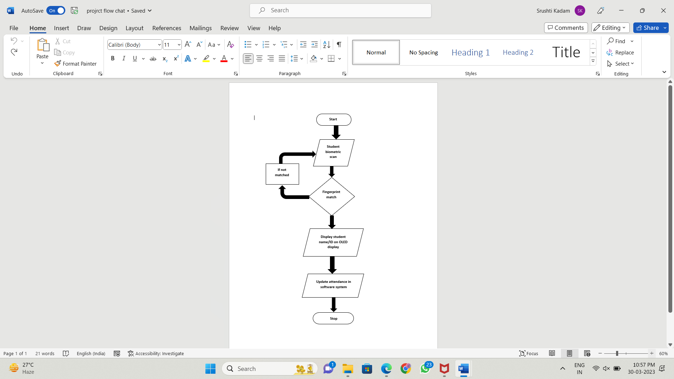

**Fig.1**

1. *Hardware and Software Modules:*

The most common set of requirements defined by any operation system or software application is the physical computer resource, is also known is hardware. We have used Node MCU which is the main hardware component through which data will be transferred to online database. It has in build Wi-Fi which helps to transmit data wirelessly. Fingerprint Reader 307, as shown in Fig. 2. To scan fingerprint. We have used C++ language to interact with hardware. Fingerprint detection algorithms are executed to register and validate the respective biometric data. HTML, CSS and SQL languages are executed for website development.

Fig.2. Block Diagram for Attendance management system

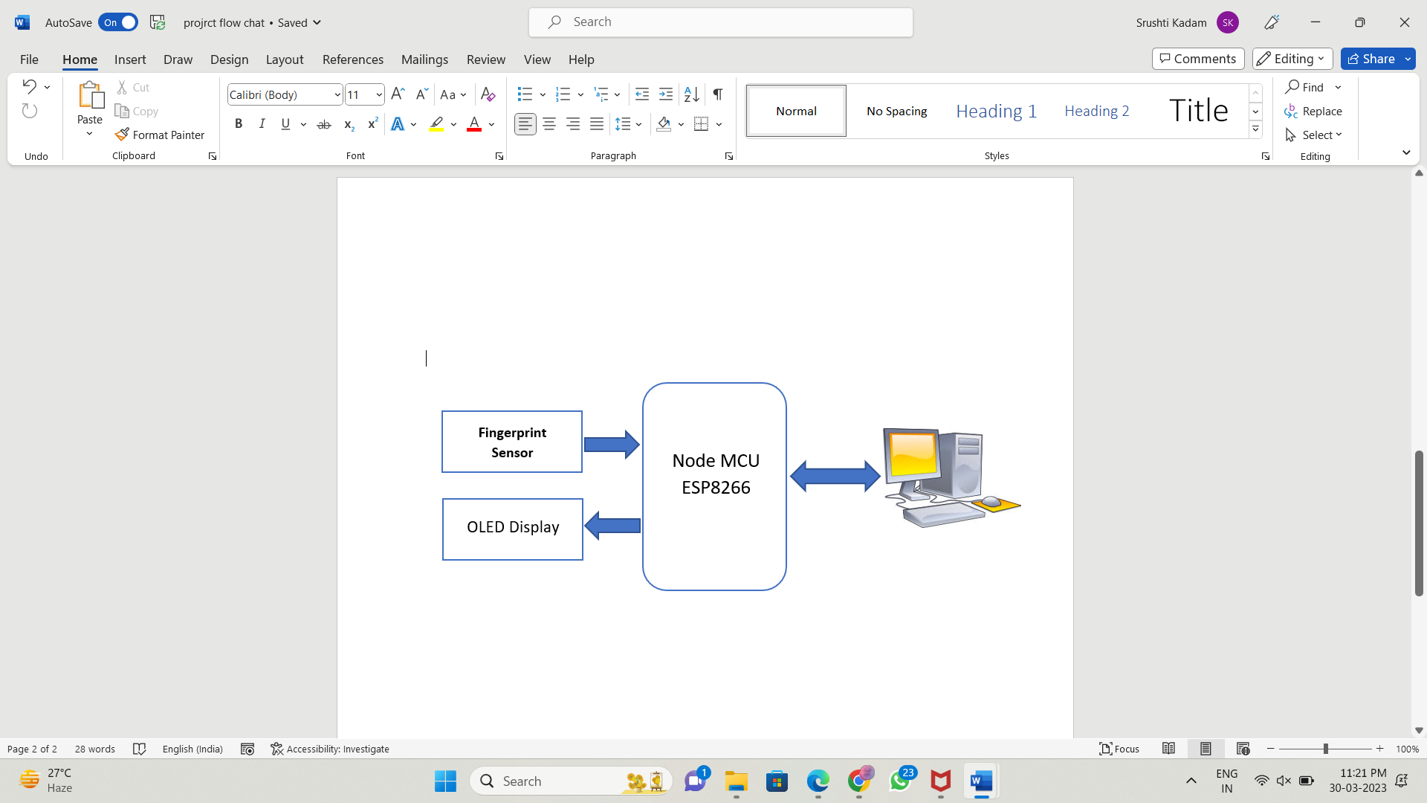

**Fig.2**

1. *Optical Fingerprint Reader 307:*

In our fingerprint module sensor is able to enroll new finger as well as detect already existing finger. Fingerprint data gets stored in Fingerprint Reader 307 module itself. R307 can store up to 1000 fingerprints. R307 is capable of independent fingerprint collection, fingerprint compression, fingerprint registration and fingerprint search function. R307 can be accessed by using PyFingerprint Library. Fig 3. Optical Fingerprint Reader 307

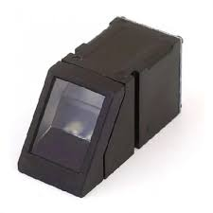

**Fig.3.**

In our system, Fingerprint Reader 307 module performs Fingerprint collection, Fingerprint compression and Fingerprint detection search. These features are performed at different stage of project.

* Fingerprint Collection: A dataset is created for new fingerprint samples to be used for further recognition.
* Fingerprint Compression: The user needs to enter fingerprint twice to validate the new fingerprint. Once user enters finger second time it gets stored at new position. It gives error “Fingerprint Don’t Match” upon compression if in case user enters different finger during validation.
* Fingerprint Search: When already entered finger is entered, the module checks where it is already present in the dataset by comparing it position number.

1. *Node MCU ESP8266:*

The project is IOT based device which is used to be connected to begin the operation. IOT we can easily hardcode the Wi-Fi SSID and Password in our program and make it word. But when the device is handed over the costumer, they should be able to scan and connect with Wi-Fi network without changing the password, this is when ESP8266 Wi-Fi manager will be helpful. This Wi-Fi manager function is added to the existing program to provide option to user to scan and connect to any Wi-Fi network and once connection is established the device can perform its normal function until the network connection has to be change again.

Fig.4 Node MCU.

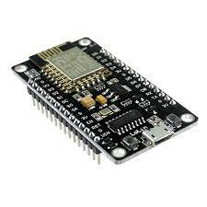

**Fig.4.**

1. SYSTEM ARCHITECTURE

This fingerprint-based attendance management system is made up of following:

* Enrollment phase
* Identification phase
* The system database

1. *Enrollment Phase:*

Users are enrolled and their fingerprint is captured into the system database. During enrollment fingerprint are captured and unique feature are extracted from fingerprint image and stored into database stored with user ID or user name. During this process user has to enter finger print twice. Fig.5. Fingerprint enrollment

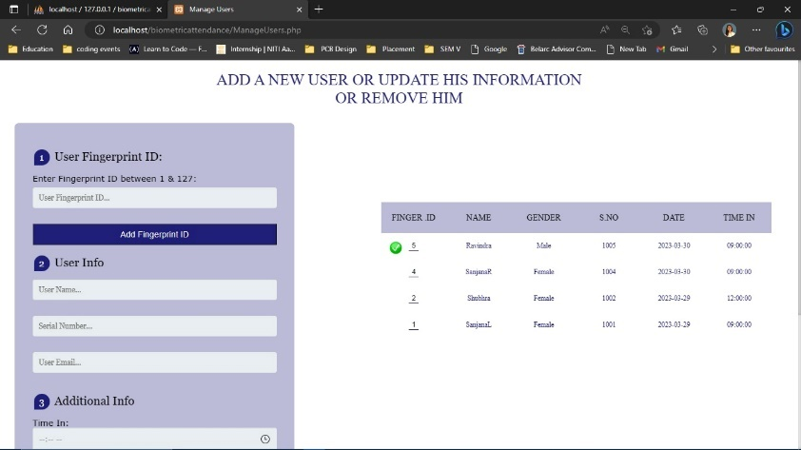

**Fig.5.**

1. *Identification phase:*

This phase is to identify users captured data. Each day of attendance the fingerprint image is extracted from an individual user, and the system conducts the one-to-many comparison to establish a individual identity.

1. *The system database:*

The system consists of tables that stores records, each of which corresponds to an authorized person that has access to the system. Each record may contain the minutiae template of the person’s fingerprint and user’s other details. Fig. 6. System database.

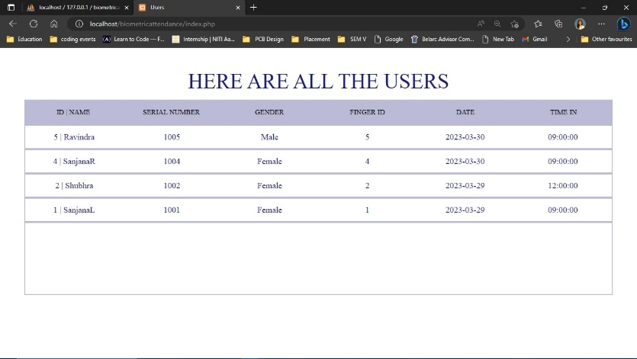

**Fig.6**

1. BIOMETRIC RECOGNIZATION

For the biometric recognition module, we provide fingerprint as the input. The input is a finger to the R307 Biometric Module which is then converted into a greyscale image as shown in Fig.7



**Fig.7**

Biometric Recognition is required in 2 parts of the system. First, while registering the fingerprint for the first time. This process takes places as shown in Fig. 8

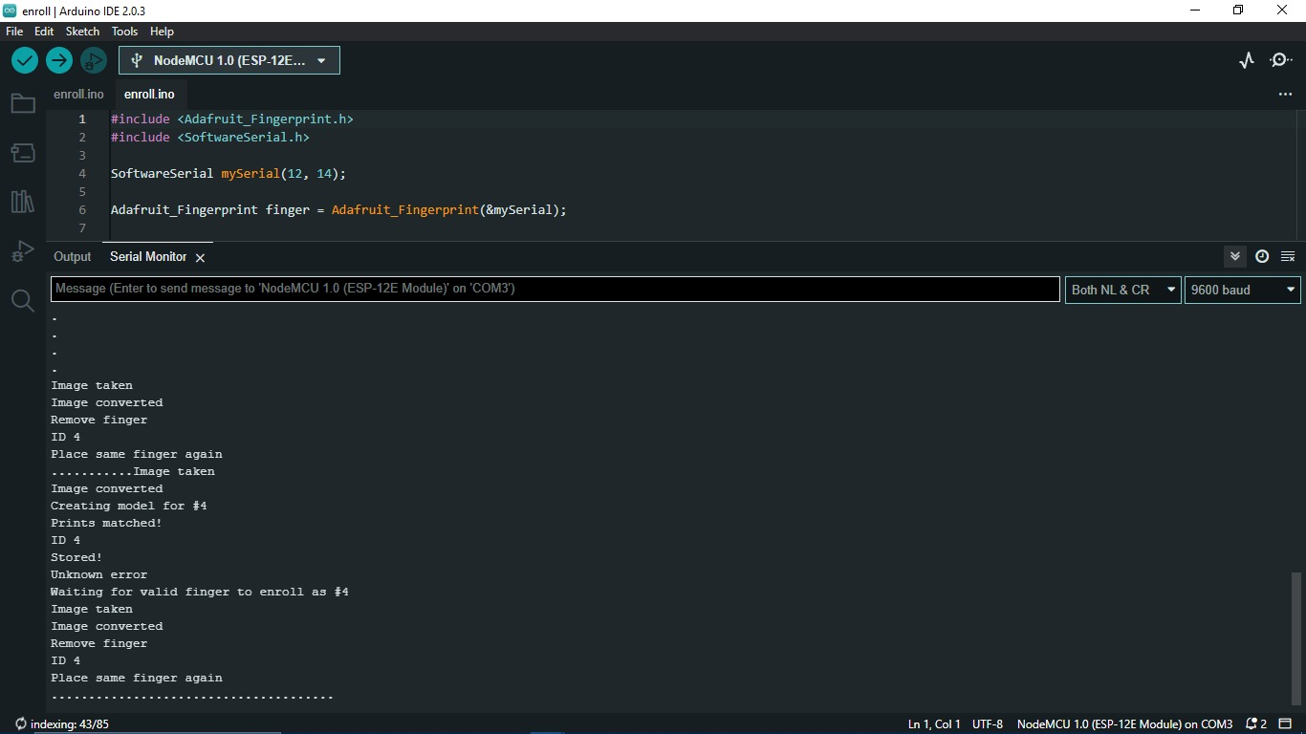

**Fig.8**

1. RESULTS

All the components are assembled and tested successfully. Hardware circuit is successfully working and is connected to the website thought which attendance will be marked. When the attendance is marked successfully user name or ID gets displayed on the OLED screen and when fingerprint is not detected OLED shows fingerprint not detected. Users can edit their previous uploaded details through website. Admins can download the attendance sheet in Excl format for proper review purpose.

1. CONCLUSION

This system ensures a quick, hassle free and paperless system suitable for classrooms of the 21st century. The manual updating of attendance and its calculation has now been replaced with a better system that features a fully automated process of attendance which provides:

1) Reduction, if not complete removal, of false attendance entries.

2) Reduced load on teachers to maintain attendance registries.

3) Easier analysis of attendance.

4) Extremely secure database where no issue of tampering can occur.

We would recommend this system for use in schools and

colleges as a replacement to the current scheme.

1. FUTURE SCOPE

* The size can be brought down to allow easier usage.
* A mobile phone application for the students could be developed which would allow them to track their attendance easily.
* The system could possibly be made more secure by using other forms of bio-metric data such as retinal scans, facial or voice recognition, etc.
* Informing the involved parties if a student’s attendance falls below the threshold.
* Use of a touchscreen instead of LCD and buttons to reduce space.
* Inclusion of a wireless charging mechanism
* Info-graphics to observe trends in students’ attendance patterns as a form of feedback.

REFRENCES

1. Happy N. Monday, Jian P. Li, Grace U. Nneji, ”, IEEE 2020 International conference on multimedia technology.
2. Mahesh P Potadar, Vaibhav V Marathe, Akshay S Khose, Lokesh A Kotkar, “Biometric Attendance Recording and Communication System”
3. Varun Panditpautra, Adrija Goswami, Aishwarya Khavare, Prof. Sarita Ambadekar, “Biometric Attendance Management System using Raspberry Pi”
4. Mohamed Basheer K P, Raghu C V, “Fingerprint Attendance System for classroom Needs”, India Conference (INDICON), Annual IEEE 2012.
5. M A Meor Said,M H Misran, M A Othman, M M Ismail, H A Sulaiman,A Salleh, N Yusop, “Biometric Attendance”, 2014 International Symposium on Technology Management and Emerging (ISTMET 2014).
6. LI Jian-po, ZHU XU-ning , LI Xue, ZHANG Zhi-ming, Ji Sheng SUI ,“Wireless fingerprint attendance system based on Zigbee Technology”, IEEE 2010 2nd international workshop on intelligent systems and applications.
7. Amir Nizam Ansari, Arundati Navada, Sanchit Agarwal, Siddharth Patil, Balwant Sonkamble, “Automation of Attendance system using RFID ,Biometrics, GSM modem with.. Net framework”, IEEE 2011 International conference on multimedia technology.